**Create profile test case**

**Goal:**

As a tester, I want to verify if the Create Search Profile form is correctly working ad if the formulary is filled properly.

**Background:**

Create Search Profile page is responsible for the creation of a profile according to the user specifications.

**Steps to Reproduce**

1. Go to <https://www.find-a-house.nl/en/home> and click on the menu bar

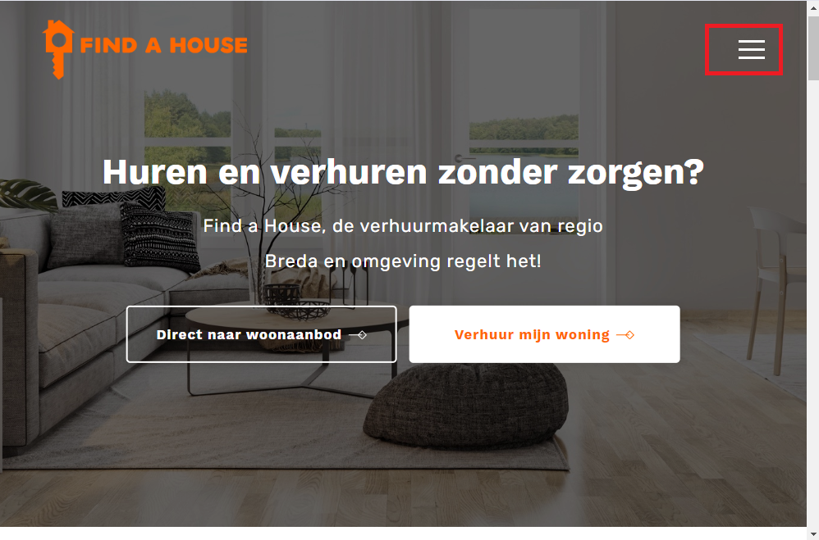

2. Click on the “Inloggen” Button to open the Login form.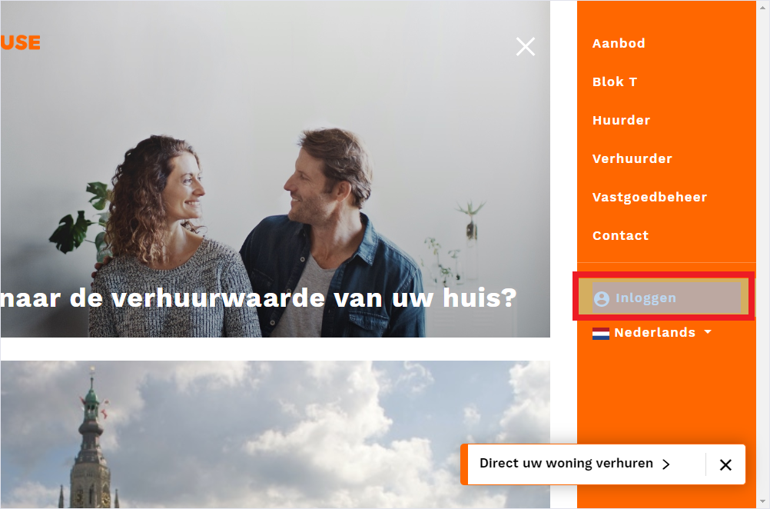

3. type an email account and password and click on the button “Inloggen.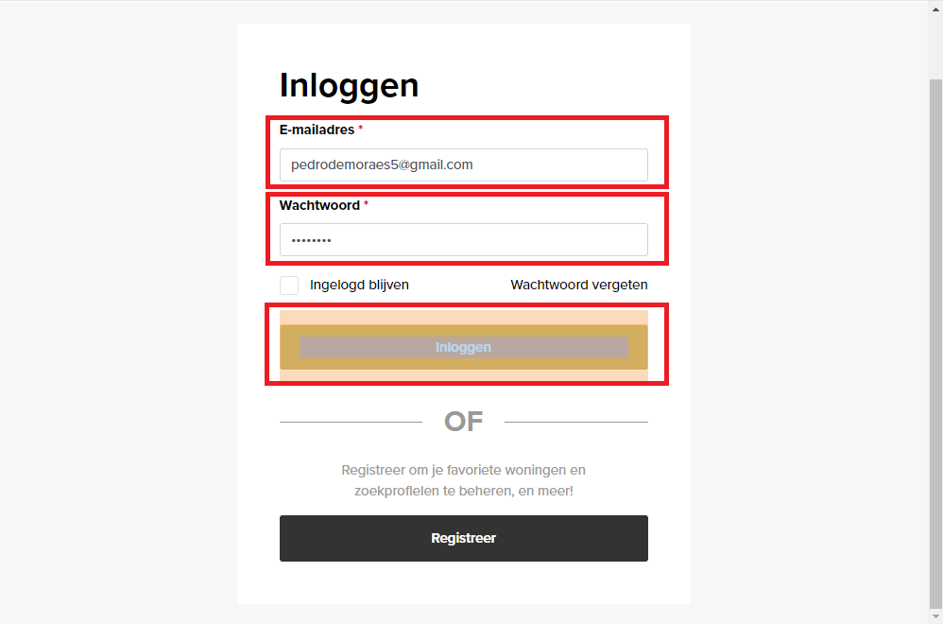

4. After the Login has been effectuated, click on the “zoekprofiel toevoegen.” 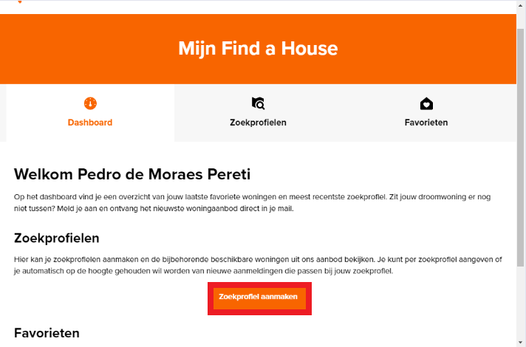

5. After opening the Search profile page, fill in the information and click on the button “Zoekprofiel opslaan.” 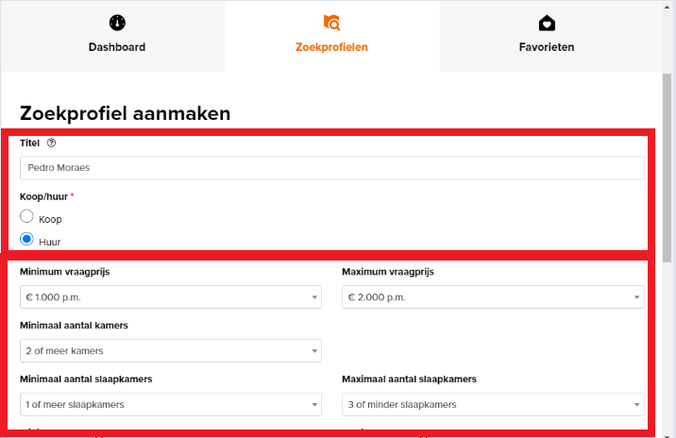

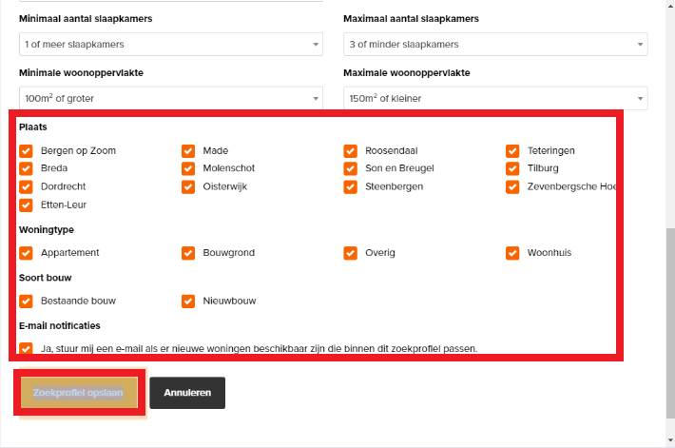

6. By the end of the procedure, the profile will be created.

